Biased expectations about future choice options predict sequential economic decisions

Didrika S. van de Wouw, Ryan T. McKay, Nicholas Furl

Royal Holloway, University of London

Corresponding author:

Nicholas Furl

Department of Psychology

Royal Holloway, University of London

Egham, TW20 0EX, United Kingdom

nicholas.furl@rhul.ac.uk

Acknowledgements: R.M. acknowledges funding support from the NOMIS Foundation (“Collective Delusions: Social Identity and Scientific Misbeliefs”).

Author contributions: D.vdW., R.M and N.F. designed the studies. D.vdW. and N.F. conducted data collection. D.vdW. and N.F. contributed to data analysis. D.vdW., R.M. and N.F. contributed to manuscript writing.

Competing interests: We know of no financial nor non-financial competing interests.

Abstract

Considerable research has shown that people make biased decisions in “optimal stopping problems”, where options are encountered sequentially, and there is no opportunity to recall rejected options or to know upcoming options in advance (e.g., when flat hunting or choosing a spouse). Here, we use computational modelling to identify the mechanisms that best explain decision bias in the context of an especially realistic version of this problem: the full-information problem. We eliminated a number of factors as potential instigators of bias. Then, we examined sequence length and payoff scheme: two manipulations where an optimality model recommends adjusting the sampling rate. Here, participants were more reluctant to increase their sampling rates when it was optimal to do so, leading to increased undersampling bias. Our comparison of several computational models of bias demonstrates that most participants maintain these relatively low sampling rates because of suboptimally pessimistic expectations about the quality of future options (i.e., a mis-specified prior distribution). These results support a new theory about how humans solve full information problems. Understanding the causes of decision errors could enhance how we conduct real world sequential searches for options, for example how online shopping or dating applications present options to users.

Introduction

Often in everyday life, decisions must be made regarding options presented in sequence. For such scenarios we can ask ourselves, when should we stop evaluating new information and commit to a decision? This common real-life dilemma can be defined as an optimal stopping problem. For example, if one encounters a limited time offer whilst shopping, should one accept it when it is available or pass on it and wait for a better one? If a doctor needs a healthy organ for transplant, should they use what is available now or risk waiting for a healthier one? If an animal welfare charity is visiting homes to find a suitable environment to rehome an animal, should they accept the currently visited home or continue to visit homes in hope of a better one? This general problem is often referred to as the "fiancé(e) problem", by analogy to decisions about whether to reject a current suitor in the hope of meeting better prospects in the future. We shall see below that solving many of these problems optimally is computationally challenging and that participants (when compared to the optimal solution) can under some circumstances show systematic decision biases. Our aim here is to delineate the experimental contexts in which participants exhibit these biases and to fit theoretical models to participants’ choices to identify the computational mechanisms that give rise to these biases.

There are many types of optimal stopping problem and their potential computational solutions have been discussed in the fields of mathematics (Ferguson, 1989), behavioural ecology (Castellano et al., 2012; Castellano & Cermelli, 2011), economic decision making (Baumann et al., 2020; Seale & Rapoport, 1997, 2000), cognitive science (Lee, 2006) and neuroscience (Costa & Averbeck, 2015). The computational solutions considered for optimal stopping problems are closely related to probabilistic reasoning and explore/exploit foraging decisions (Averbeck, 2015) and other sequential tasks that involve prospective reward prediction (Kolling et al., 2018; Scholl et al., 2022). The availability of optimal computational solutions to optimal stopping problems enables researchers to use them as “ideal observer models”, which can identify when people make suboptimal decisions, including decisions that reveal systematic biases.

We focus in the present study on a bias that arises for *“full information problems”*. This version of optimal stopping problem arguably most closely resembles real-world decision problems. Imagine an agent is searching for a new flat in a competitive market. The agent can sample a limited number of options in sequence (e.g., twelve flats can be viewed, one at a time) and must decide, for each option, whether to stop sampling and choose that option, under the condition that rejected options cannot be returned to later (e.g., refused flats are then offered to others and so become unavailable). Flat hunters in full information problems directly know the value of each option (e.g., how nice the currently viewed flat is or how much it costs). Full information problems can incorporate flexible payoff schemes (e.g., an agent might feel rewarded only if they achieve the best possible flat or their subjective reward might depend on the relative quality of whatever flat is chosen). Full information problems may involve a “cost to sample”. Each time a new flat is visited (i.e., a new option is sampled), our flat hunter may incur calculable costs such as time, money or effort, which may be subtracted from the final achieved reward value and so can limit how many options are sampled. Finally, full information problems allow agents to harness their prior belief about the probability distribution that is generating their decision options (i.e., the generating distribution). When flat hunting, consumers can use these *prior expectations* about the housing market to prospectively compute the probability that an even nicer flat might be sampled if the current one is refused.

Here, we will use experimental methods and computational modelling to test a raft of hypotheses related to an “undersampling bias”. When the sampling behaviour of ideal observers is compared to that of human participants, humans often sample fewer options than is optimal (e.g., Baumann et al., 2020; Cardinale et al., 2021; Costa & Averbeck, 2015; Goldstein et al., 2020; Guan & Stokes, 2020). To date, this undersampling bias has mainly been demonstrated for optimal stopping problems cast in economic scenarios in which options are represented as numbers (e.g., prices). Here, we have adapted the economic task first reported by Costa and Averbeck (2015). In our version, participants attempt to choose high-ranking smart phone prices.

However, undersampling bias is by no means universal. For example, some new studies have reported full information problems associated with oversampling rather than undersampling (Furl et al., 2019; van de Wouw et al., 2022). These studies employed several different experimental and modelling methods that might have ameliorated the undersampling bias. Herein, we systematically manipulated each of these methods, demonstrating that undersampling bias is increased for longer sequence lengths and for payoff schemes that reward only top-ranking choices, and we rule out the other methods as potential sources of bias.

What computational mechanisms account for participants’ errors on this task? We created theoretical computational models, each with a free “bias” parameter that skews otherwise optimal performance. We show (replicated across multiple studies and conditions) that participants’ sampling decisions on our economic task are best explained by a theoretical model that makes inaccurate expectations of the quality of upcoming options, based on a mis-specified belief about the prior option distribution.

General Methods

Paradigm summary

First, we briefly describe the features of our paradigms that are relevant for understanding the operations of our computational models. More specific methods for individual studies will be described in separate sections later. All study protocols were approved by the Royal Holloway, University of London College Ethics board and informed consent was obtained from all human participants in compliance with these protocols. Only Study 3 was pre-registered.

We implemented full information optimal stopping problems in which participants attempted to choose a competitive mobile phone contract. Prices used for all studies reported herein were for flagship models by the top brands (e.g., iPhone, Samsung, Huawei), on an up to 5GB plan with unlimited texts and minutes. The 90 prices were actual prices (in GBP) of 2-year contracts offered by various UK retailers, as harvested from internet advertisements in the year before data collection. The use of these real-world prices was intended to maximise the likelihood that the distribution of option values used in our studies would approximate the “true” generating distribution of smartphone price options in the participants’ local market and thereby also approximate any prior expectations participants derived from their experience with smartphone contract prices.

In some conditions, the paradigm began with a “phase 1” ratings task, in which participants gradually viewed the full distribution of prices that could appear as options later by rating every price for its “attractiveness” or subjective value. As described below, some models operate on objective values / raw prices (OV) and other models operate on the subjective value of the prices (SV), derived from the ratings measured during phase 1. In phase 1, participants also could learn the “generating” distribution of option values and thereby establish expectations about the probabilities with which certain option values might appear in any given sequence, later in the optimal stopping task. The distribution of these ratings could then be used to set the models’ prior on its generating distribution of option values (See *Ideal observer optimality model* section).

Next, in the optimal stopping task, participants engaged with several fixed-length sequences of option values, populated by prices sampled randomly, without replacement, from the phase 1 generating distribution. In each sequence, participants sequentially encounter these prices and, for each, decide whether to reject that price (rendering it no longer accessible) and sample a new one, or to take / choose that price. The decision to take a price terminates the search through the sequence and renders the upcoming new prices no longer accessible. If the last price in a sequence is reached, that price becomes the participant’s choice by default.

Our main behavioural dependent variable for the participants and all our models was the number of samples before decision (another performance measure, the rank of the chosen prices, is reported in Supplementary Materials for participants and all our models). We computed frequentist and Bayesian *t*-tests using bf.ttest in the MATLAB bayesFactor toolbox <https://github.com/klabhub/bayesFactor> to compare these variables between participants and ideal observers and to compare participants’ sampling rates between study conditions.

Ideal observer optimality model

To analyse the optimal stopping task, we compared the number of options our participants sampled before choosing an option to that of the Ideal Observer. The Ideal Observer is a benchmark of optimality, for which performance is Bayes-optimal. This finite-horizon, discrete-time, Markov decision process (MDP) model has been used in previous studies (Cardinale et al., 2021; Costa & Averbeck, 2015; Furl et al., 2019; van de Wouw et al., 2022). The Bayesian version of the optimality model for the full information problem builds on the classic Gilbert and Mosteller model (Gilbert & Mosteller, 1966). Models try to predict upcoming option values, with these expectations derived from the model’s belief about the distribution from which future options are assumed to be generated (i.e., the generating distribution). More precisely, the utility *u* for the state *s* at sample *t* is the maximal action value *Q*, out of the available actions *a* in *A*. These action values in turn depend on the reward values *r* and the probabilities of outcomes *j* of subsequent states (i.e., the generating distribution), weighted by their utilities.

$$u_{t}\left(s_{t}\right)=\max_{a∈A_{s_{t}}}\left\{r_{t}\left(s_{t},a\right)+\int_{s}{p_{t}(j|s_{t},a)u_{t+1}(j)d_{j}}\right\}$$

The terms appearing inside the curly brackets are taken collectively as the action value *Q*. $r_{t}\left(s_{t},a\right)$ is the reward that would be obtained in state *s* at sample *t* if action *a* is taken. The model described here reduces *r* by costs incurred by sampling again using a “cost to sample” penalty term *C*. See formula for $r_{t}\left(s_{t},a=sample again\right)$ below. As there was no extrinsic cost-to-sample in any of our experimental designs herein, *C* was always fixed to zero for the ideal observer. The integral is taken over the possible states subsequent to the current sample. Each of these states is weighted by the probability of transitioning into it from the current state, given by $p_{t}(j|s_{t},a)$, as derived from the generating distribution.

The utilities for sampling again are computed based on backwards induction (See Supplementary Materials for more detailed explanation on this algorithm). The model first considers the utility for the final sample *N* in the sequence, which is simply the reward value associated with the *N*th state (because taking the option is the only available action for the final sample in a sequence).

$$u_{N}\left(s_{N}\right)=r\left(s_{N}\right) for all s_{N}∈N$$

Next, the model works backwards through the sequence, iteratively using the aforementioned formula for $u_{t}\left(s_{t}\right)$ when computing each respective action value *Q* for taking the option and declining the option for each *t*. Whenever the reward value of taking the current option is considered, the reward function *R* assigns reward values to options based on their ranks. *h* represents the relative rank of the current option.

$$r_{t}\left(s_{t},a=take\right)=\sum_{i=1}^{N}{p\left(rank=i\right)*R(i+\left(h-1\right))}$$

In contrast, the reward value of sampling again is simply the cost to sample *C*.

$$r_{t}\left(s_{t},a=sample again\right)=C$$

This customisable *R* function allowed us to examine how the ideal observer changes its sampling strategy under the different reward payoff schemes used in our studies. We will see in later sections that the studies and experimental conditions named Pilot full, the full condition of Study 1, Study 2 and both sequence length conditions of Study 3 all involve instructing participants to try to choose the best price possible. In study conditions using these instructions, we implemented a continuous payoff function (resembling that of the classic Gilbert & Mosteller formulation), in which the relative rank of each choice would be rewarded commensurate with the value of its associated option. In Pilot baseline and the baseline, squares, timing, and prior conditions of Study 1, we implemented the payoff scheme to match participants’ instructions that they would be paid £0.12 for the best rank, £0.08 for the second-best rank, £0.04 for the third best rank and £0 for any other ranks. Lastly, in the payoff condition of Study 1, we programmed the reward payoff function to match participants’ reward of 5 stars for the best rank, 3 stars for the second-best rank, one star for the third-best rank and zero stars for any other ranks.

Another feature added to our implementation of the ideal observer, compared to the Gilbert & Mosteller base model, is the ability to update the model’s generating distribution from its experience with new samples in a Bayesian fashion, instead of this generating distribution being specified in advance and then fixed throughout the paradigm. Our Bayesian version of the optimality model treats option values as samples from a Gaussian distribution with a normal-inverse-*χ2* prior. Before experiencing any options, the prior distribution has four initial parameters: the prior mean *μ0*, the degrees of freedom of the prior mean *κ*, the prior variance *σ*20 , and the degrees of freedom of the prior variance *ν*. This initialised distribution plays the role of a prior generating distribution when the first option value is sampled. The *μ0* and *σ*20 parameters of the generating distribution are then updated by the model following presentation of each newly sampled option value as each sequence progresses.

Here, we set the prior values of *μ* and *σ*2 in two possible ways: objective value and subjective values versions. In some previous studies of price decisions, the mean and variance of the generating distribution has been fixed in advance by the mean and variance of the distribution of objective prices (e.g., Baumann et al., 2020). We implemented an objective values version of the ideal observer in this way for all the study conditions reported herein. This objective values procedure for the ideal observer assumes that the raw prices can be treated as a proxy for participants’ subjective value of the prices, so an Ideal Observer that optimises only the raw prices when making decisions would therefore be an appropriate basis for comparison with participants. However, we also had direct access to subjective values of options in some conditions, due to the presence of the initial rating phase. In the conditions for which we had subjective values from the initial phase available (Pilot full, Study 1 full condition, Study 1 ratings condition, Study 2 and both sequence length conditions of Study 3), we could also build an subjective values version of the Ideal Observer. This second way of computing the Ideal Observer assumes that participants’ subjective valuation of prices may not necessarily exactly equal the raw price values, especially in their scaling, which may be relevant to full information problems. We used each participants’ individualised ratings (subjective valuations) of the prices as option values input to the subjective values version of the Ideal Observer, and we used the mean and variance of individual participants’ ratings distributions when initialising the prior of the generating distribution of the Ideal Observer.

Because conditions with an initial rating phase had two versions of the Ideal Observer, each providing separate optimality estimates (objective and subjective values versions), we were able to test the hypothesis that the use of objective or subjective values when modelling affects the strategy taken by the optimality model and, when empirically compared to participants’ strategies, whether it changes the assessment of participant bias. We ensured for both OV and SV models that better options were always more positively-valued such that the models were always solving a maximisation problem. We further ensured that estimated parameters for OV and SV models would be on the same scales. We achieved this by reflecting the prices around their mean. Then we rescaled the values to span 1 (the highest / worst price) to 100 (the best price). These reflected and rescaled objective values were then used in OV models when computing the prior generating distribution (subjective value ratings were already made by participants on this 1 to 100 scale), and when inputting price values to the model as option values.

Theoretical models

The purpose of the Ideal Observer described above was to assess bias, not to theoretically explain participants’ bias. By the definition of an ideal observer, its parameter values should be fixed to ground truths established by the experimental design. Because of this feature, however, ideal observer models in general are not appropriate for use as theoretical models of potentially biased human sampling and choice behaviour, without modification added to account for sources of individual variability in bias. That is, the ideal observer only models the computations leading to accurate choices but not to systematic sources of error. To better understand which computations might be responsible for participants’ errors, we formulated a number of theoretical models and fitted them to participants’ take option versus sample again choices. As mentioned above with respect to ideal observer models, some previous studies have implemented models which aim to optimise the objective values of choices (e.g., Baumann et al., 2020; Cardinale et al., 2021; Costa & Averbeck, 2015; Lee, 2006) while other model implementations optimise subjective values of those options, obtained via a separate rating task (Furl et al., 2019; van de Wouw et al., 2022). Because there is no obvious determination of which procedure is correct, we implemented both objective values and subjective values versions of all our theoretical models, whenever a study condition involved a preceding rating task that enabled both model implementations. Then, we could assess using model comparison whether OV or SV models best fit human participant choices, or whether OV and SV models are relatively interchangeable (which we in fact discovered, see Results).

For every sample, the probabilities of the two available choices (take current option versus sample again) were computed by transforming action values from each model to probabilities using Softmax and then summing negative log likelihoods over choices for each participant. In each model, we freed one theoretically interpretable key parameter (these free parameters and their models are described below) and the inverse temperature parameter beta from the Softmax function (the starting value for beta was always 1 and the fitting of beta was bounded between 0 and 200). Variability in each of the key theoretical parameters was confirmed during parameter recovery (See Supplementary Text) to be capable of modulating the sampling rate (Figure S5). The two free parameters per model were fitted using fminsearchBND.m in MATLAB (Mathworks, Natick MA). Parameter recovery analyses for three of the models we consider and describe below showed at least adequate correlations between configured and recovered parameters (Figure S4): The Cut Off heuristic and the Cost to Sample and Biased Prior models (See Table 1 for model summaries). These models also showed strong correlations between sampling rates associated with configured parameters and sampling rates associated with recovered parameters. Two other theoretically motivated models – the Biased Values and Biased Rewards models (See Supplementary Materials) – performed more poorly during parameter recovery and so were excluded from the formal model comparison. We implemented two parallel model comparison methods based on negative log likelihood values converted to Bayesian information criterion (BIC) values. For the first model comparison method, we submitted the BIC values to repeated measures pairwise statistical tests using Bayes factors to ascertain whether pairs of models differed or had equivalent BIC values on average over participants. The better models show statistically lower BIC mean values. For the second model comparison method, we computed which model had the lowest (best) BIC for each participant and then plotted histograms to ascertain which model(s) dominated the others in terms of participant “wins”. The model that best-fitted the most participants presumably was the sampling strategy most often used by participants in our sample.

|  |  |  |
| --- | --- | --- |
| Model name | Free parameters | Strategy |
| Cut Off heuristic | Cut off,  Softmax beta | Chooses no option until after a “cut off” number of samples, then chooses next option with highest relative rank. |
| Cost to Sample | Cost to sample,  Softmax beta | Ideal Observer, but sampling can be perceived as costly. |
| Biased Values | Option value threshold,  Softmax beta | Ideal Observer, but only option values above a threshold can be considered. |
| Biased Prior | Constant added to prior mean,  Softmax beta | Ideal Observer, but expected value (mean) of prior option value distribution can be reduced by a constant. |

Table 1. Key features of fitted theoretical models

The objective and subjective values versions of the *Cut Off Heuristic* derive from the mathematically-optimal solution to the “Secretary problem” (Ferguson, 1989), a distinct optimal stopping problem with a mathematical solution that is relatively simple, due to an abundance of required assumptions that need not hold for full-information problems. Namely, the secretary problem solution assumes the agent uses no prior knowledge of the generating distribution, considers only relative ranks of option values and feels rewarded only when choosing the top-ranked option. Although this heuristic derives from the optimal solution to a different optimal stopping problem than the full information problem we consider here, Todd & Miller (1999) propose that this heuristic might nevertheless be robust to violations of the secretary problem assumptions and, as a heuristic, would be relatively simple for humans to compute on the fly in realistic settings. More specifically, Todd & Miller (1999) propose that such a Cut Off heuristic can explain undersampling bias as the model can perform nearly-optimally (on secretary problems) while incurring fewer samples, which “satisfices” under conditions where the problem involves a ground truth cost for new samples (note, however, that the Cut Off heuristic has no formal cost to sample parameter). This heuristic has previously been fitted to human behaviour on full information optimal stopping problems, although little evidence was found favouring it in that study (Baumann et al., 2020). The Cut Off heuristic chooses to sample again for every option until it reaches a cut-off sequence position, which is fitted as the key theoretical free parameter. Then, the model continues to sample until it reaches the next option with the highest relative rank so far. Here, we used the optimal cut-off value (37% of the sequence length, rounded to the nearest integer) as the starting value during model fitting and the parameter search was bounded between 2 and the sequence length minus 1 (as the learning period defined by the cut-off must contain at least one sample and be followed by at least one sample available for choice). Cut-off values below the optimal value lead to undersampling and cut-off values above the optimal value lead to oversampling.

We also considered objective and subjective values versions of *the Cost to Sample model*. These use the Bayesian ideal observer described above as a base, while also assuming that participants’ otherwise rational Bayesian computations can be biased by a free parameter value. In the case of the Cost to Sample models, the fitted parameter to account for such bias was the cost to sample value *C* (See computation of $r_{t}\left(s_{t},a=sample again\right)$ in the Ideal Observer Optimality Model section above. In such a model, participants would undersample if they intrinsically perceive sampling as costly and so adopt a negatively valued *C,* and would oversample if they perceive sampling as rewarding as so adopt a positive *C*. We initialised model fitting with a starting *C* value of 0 (i.e., the optimal value) and, during fitting, bounded *C* to be between -100 and 100.

We used a similar approach when building the subjective and objective values versions of the *Biased Prior model*. In this model, we added a new free parameter to $u_{0}$, the mean of the prior generating distribution. Negative values of this parameter can bias an agent to compute pessimistic estimates of future option values by shifting the prior mean (i.e., expectation) to be lower. This can lead to undersampling by making the current option appear more appealing compared to the artificially deflated expectation of option values resulting from continued sampling. We initialised model fitting with a starting value of 0 (i.e., the optimal value) and the biased prior parameter was bounded during fitting to be between -100 and 100.

Pilot Studies Methods

Participants

We recruited participants in both our pilot studies from the United Kingdom using the online data collection platform Prolific (Prolific, 2014). We enrolled 50 participants into Pilot Baseline and 51 participants into Pilot Full.

Procedures

We used Gorilla Experiment Builder (Anwyl-Irvine et al., 2020) to create and host Pilot baseline and Pilot full studies. For Pilot baseline, we attempted to replicate participant undersampling bias (Cardinale, et al., 2021; Costa & Averbeck, 2015), in which participants sampled fewer options than the same Ideal Observer that we used herein. Therefore, we matched the methods of Pilot baseline to Costa and Averbeck (2015) as closely as was practical, while adapting the paradigm for an online data collection setting. As Pilot baseline is representative of all our paradigms, we illustrate it in Figure 1, while screenshots from other conditions are shown in Supplementary Figures S1, S2 and S3. There was no phase 1 ratings task in Pilot baseline. In the Pilot baseline optimal stopping task, participants attempted to choose one of the top three ranked smartphone prices out of each option sequence. The option value screen also presented the previously rejected option values and the number of options remaining in the sequence. Each sequence used a fixed order of 12 option values, so a given sequence’s option values and their order within the sequence was identical for every participant (and corresponding models), although the sequences themselves were intermixed randomly.

Figure 1. Baseline pilot paradigm. Participants are instructed to buy a smartphone (A), view option values for a fixed duration (B), choose to take the option or sample another (C) and, upon taking an option, receive feedback (D) about the reward value of their choice (monetary remuneration when top three ranked options are chosen).

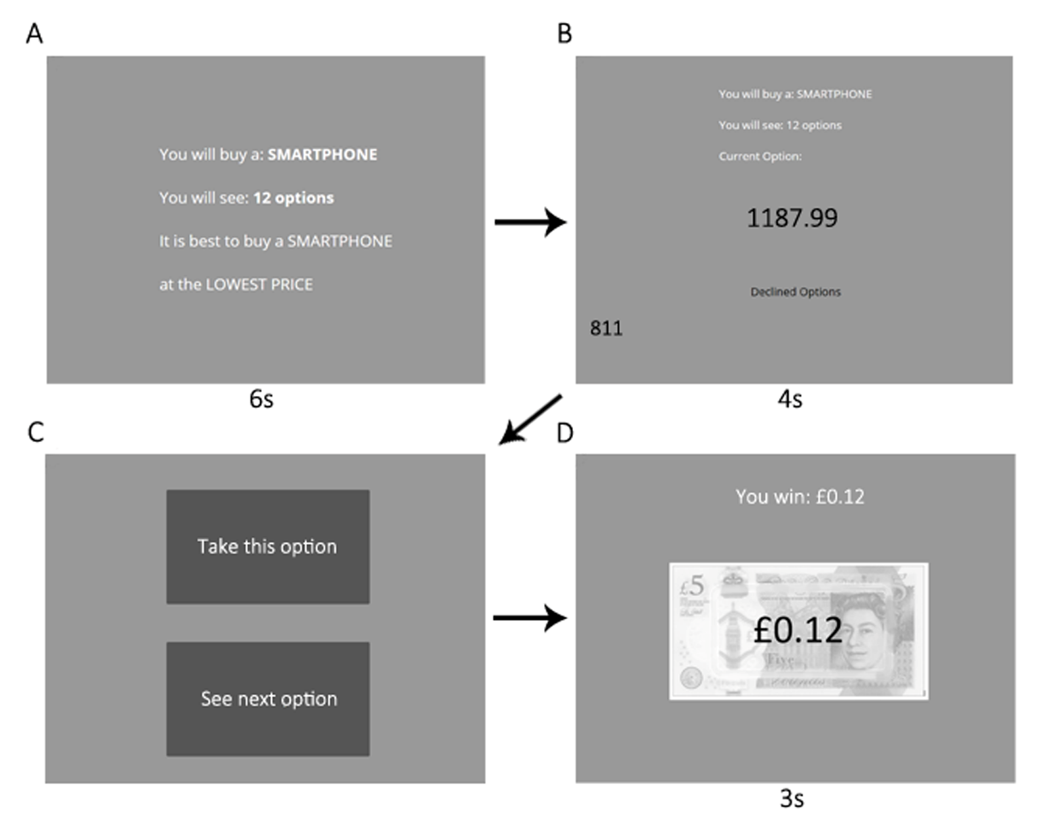

Like Costa and Averbeck (2015), we rewarded participants financially for choosing one of the top three options in the sequence. Participants in Pilot baseline earned £0.12 per sequence if they chose the best price in the sequence, £0.08 if they chose the second-best price, £0.04 if they chose the third best price, and £0 if they chose any other option. These performance-based bonus payments were earned on top of a flat fee, which for all our studies was set in line with Prolific’s recommended pay of £7.50 per hour (participants typically finished the study in considerably less time than an hour). Once a choice was made, participants viewed a feedback screen that informed them of their winnings for that sequence. The paradigm utilised fixed screen timings, meaning that participants automatically advanced through the screens, except when asked to decide (‘Take this option’ or ‘See next option’). Participants were warned about this feature in the instructions preceding the task.

For Pilot Full, we were interested in whether participant undersampling bias would continue to replicate using the same economic smartphone price task, but when implementing the “full” complement of methods particulars adapted from studies that revealed oversampling bias instead of undersampling bias (Furl et al., 2019). The logic is that, if any of these methods features is responsible for the oversampling bias seen in these earlier papers, then Pilot full should produce an oversampling bias, which would contrast with the undersampling bias we expected to see in Pilot baseline.

Pilot full added an initial ratings phase (Figure S1), in which participants rated the “attractiveness” of the price, defined in the instructions as a willingness to purchase a phone at that price. Ratings were made by mouse click on a sliding scale from 1 to 100, with the slider only appearing after the first click - to avoid slider biases (Matejka et al., 2016) - with the selected rating value shown above the slider. Participants rated 180 prices, presented one at a time in a random order, and comprising the 90 unique prices, each rated twice. The average over the two ratings for each price was then used as the subjective value input to the SV versions of the models. In Pilot full, the mean (over participants) Pearson’s correlation coefficient between the two ratings was .83. A blue progress bar was shown continuously at the bottom of the screen to visualise participants’ progression through the ratings phase.

The optimal stopping (second) phase of Pilot full (Figure S1) included five sequences of 12 option values each. As in Pilot baseline, the option values in each sequence were fixed in advance but the sequences’ order was randomised. Unlike Pilot baseline, once participants chose one of the options, they then had to advance by button press through a series of grey squares that replaced the remaining options in that sequence. This was intended to discourage participants from finishing the study early by choosing earlier options. Also unlike Pilot baseline, the optimal stopping task was entirely self-paced - participants advanced by using their mouse to click on the buttons on the screen. After finishing a sequence, participants were directed to a feedback screen displaying their chosen price and the text: "This is the price of your contract! How rewarding is your choice?". Participants responded to this question using a slider scale ranging from not rewarding (1) to very rewarding (100). The purpose of this rating activity was only to provide feedback to the participants about the quality of their choices, in lieu of the bonus payoff screen in Pilot baseline, and to encourage participants to reflect upon the choice’s reward value before moving on to the next sequence. These ratings do not provide hypothesis-relevant data and were not analysed. Participants were reimbursed a flat fee only - no bonus monetary payoff was awarded.

Pilot Studies Results and Discussion

As the two pilot studies are separate studies, with data collected at somewhat different times, we will descriptively, rather than statistically, compare them. Figure 2 shows the mean number of samples to decision made by human participants for both pilot studies, which yielded similar numbers of samples, with a slight numerical increase for Pilot full.

Figure 2. Human participants’ numbers of samples to decision for all studies. Significant pairwise differences between condition means within a study are shown as green horizontal lines (*p* < .05, Bonferroni correction for the number of pairs in each study), which appear only for the Study 3 sequence length conditions. Null effects were concluded based on *BF*01 > 3 (i.e., moderate evidence for equal means). Such pairs are connected by magenta horizontal lines.

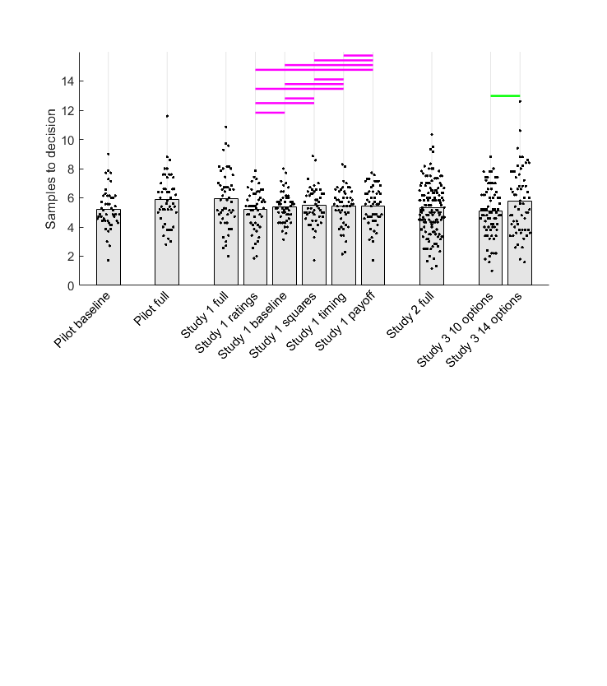

Figure 3. Model comparison for Pilot baseline (left column) and Pilot full (right column). Points in the first and second rows show data corresponding to individual participants, while bars show their mean values, which are also printed above each bar. Human participant data are reproduced from Figure 2. In the first row, horizontal lines above human and Ideal Observer samples data indicate in thin black when *BF01* > 3 (moderate evidence for equal means) or in thick grey when *BF10* > 3 (moderate evidence for different means). The second row shows BIC values (lower values indicate better model fit) for participants (points) and their mean values (bars). Horizontal lines are shown in the colour corresponding to the better-fitting model when *BF10* > 3 or in black when *BF01* > 3. The third row demonstrates that the Biased Prior model best fitted the most participants in both pilots. The legend in the lower right panel gives the color scheme for different models / participants. Abbreviations: Subj = Models that make choices about subjective values; Obj = Models that makes choices about objective values.

Figure 3 shows results from the comparison of human participants’ sampling with sampling of the ideal observer and theoretical models. As expected, we successfully replicated undersampling in the Pilot baseline condition (Figure 3, upper left), where participants sampled fewer options than the ideal observer (Cohen’s *d* = -2.52). All the theoretical models, after fitting to Pilot baseline data, resembled the participants to some degree, as they all showed some degree of undersampling, compared to the objective values version of the Ideal Observer. Bayesian pairwise tests (Figure 3, left column, second row), showed that the Cost to Sample and Biased Prior models did not have statistically distinguishable mean BIC values, but both outperformed the Cut Off heuristic in terms of mean BIC. Biased Prior was the best fitting model for most participants, though the Cost to Sample model was the best fitting model for a sizable number of participants.

For Pilot 2, our hypothesis that at least of the several additional task features would eliminate the undersampling bias observed in Pilot 1 was fulfilled. This contrast between pilot studies does not seem to arise because participants sampled differently, but rather because the ideal observer sampled less in Pilot full, compared to Pilot baseline. In Pilot full, participants’ sampling (Figure 3, top right) was statistically equivalent to sampling for the objective values version of the Ideal Observer (Cohen’s *d* = .17) and even significantly greater than sampling for the subjective values version of the Ideal Observer (Cohen’s *d* = .45). Study 1 will address which methods altered the Ideal Observer’s sampling rates in the full condition. To anticipate Study 1, we will see that the Ideal Observer samples less when all relative ranks of choices are rewarded depending on the magnitude of the option value (as in Pilot full), but it samples more when only the top three ranks are rewarded (as in Pilot baseline). Participants, in contrast to this Ideal Observer, will be seen in Study 1 to be relatively insensitive to the payoff scheme.

What computational mechanisms account for participants’ discrepancies from optimality in these pilot studies? In both studies, statistical tests comparing pairs of participant BIC values give some evidence that the Biased Prior and Cost to Sample models are both better than the Cut Off heurostic (Figure 3, middle row), though Biased Prior seems to better fit the most participants in both studies with a substantial contribution of the Cost to Sample model (Figure 3, lower row). To anticipate, we will see a similar pattern replicated across all our later studies: The most evidence favours Biased Prior as the most common model of participant performance, though there may also be a contribution of the Cost to Sample model.

Study 1

The paradigm design that we adapted to use in Pilot baseline was taken from Costa & Averbeck (2015) and above we reported how Pilot baseline indeed replicated its predecessor’s findings of undersampling. Concomitantly, we adapted many of the design features for Pilot full from studies that instead showed oversampling (Furl et al., 2019, van de Wouw et al., 2022). Above, we also report how the Pilot full study eliminated the undersampling bias by reducing the sampling rate of the Ideal Observer. This pattern raises a distinct possibility – which we test in Study 1 - that a systematic manipulation of each of the task features added to Pilot full will show at least one of them that reduces Ideal Observer sampling, though they may not also affect participant sampling. Study 1 will further give us six more datasets with which we can perform model fits and attempt to replicate our findings from the pilot studies that the Biased Prior model is most commonly the best-fitted explanation of participant performance.

Study 1 Methods

Participants

As in the pilot studies, participants in Study 1 were enrolled from Prolific’s pre-screening facility to ensure that all participants were residents of the United Kingdom, to maximise familiarity with current UK smartphone market prices, denominated in GPB. We enrolled independent participant samples into each of six conditions (See Procedures), targeting fifty participants in each condition (chosen based on our pilot studies, whose sample sizes proved sufficient to discriminate participant and Ideal Observer sampling rates). However, because of a technical difficulty with the participant recruitment platform, we overshot our data collection target by two participants, one in the timing condition and one in the ratings condition.

Procedures

The study was developed using the experiment hosting software Gorilla Experiment Builder (Anwyl-Irvine et al., 2020). We implemented six conditions in Study 1, which systematically manipulated the presence or absence of four key task features. These features are summarised in the rows of Table 2 and paradigm designs are visualised for the conditions in Study 1: baseline in Figure 1, full in Figure S1, payoff in Figure S2 and squares in Figure S3. Next, we will cover each condition in turn.

The *baseline condition* (Figure 1) was nearly identical with the Pilot baseline study, except that it implemented seven sequences instead of five. That means that, like Pilot baseline, Study 1 baseline adapted its methods from Cardinale et al. (2021) and Costa and Averbeck (2015). It is “baseline” in the sense that it possesses none of the new methodological features from Furl et al. (2019) under test here, and it will serve as the basis for comparison against the other conditions, which each add one or more of the methodological features. Like Pilot baseline, we fixed in advance the option values and their order within each of the sequences, and then these fixed-option sequences were presented in random order. However, in this case, to avoid as homogenous a set of sequences as was used in Pilot baseline, we created 10 such fixed sets of sequences and each participant was randomly assigned to one of these sets. This procedure was implemented in Study 1 baseline and in all the conditions based on it, described below (i.e., ratings, payoff, squares, timing). The *full condition* was identical to the Pilot full study (Figure S1), except that it used seven sequences instead of five. The mean (over participants) Pearson’s correlation coefficient between the two ratings for each price collected in the first phase was .87. The *ratings condition* was the same as the baseline condition with the exception that it added the same initial rating phase as Pilot and Study 1 full conditions (Figure S1), but still used the same optimal stopping task as the baseline condition (Figure 1). In this condition, the correlation between the two ratings for each price (averaged over participants) was .81. The *payoff condition* (Figure S2) was the same as the baseline condition with the exception that participants did not receive the monetary incentivisation that they did in the baseline condition. Participants were instructed to make choices to maximise the number of stars. Then, instead of receiving feedback regarding their earned bonus payments on the feedback screen (as in the baseline condition), participants were shown pictures of the number of stars that they earned for their choice: either five stars, three stars or one star, if they chose respectively the best, second best, or third best price in the sequence. The *squares condition* (Figure S3) was the same as the baseline condition with the exception that, once participants had chosen an option that was not the last option, they had to press a key to advance through grey squares that replaced each forgone option until the end of the option sequence. The *timing condition* was the same as the baseline condition with the exception that this condition incorporated a “next” button in the top right corner of every option screen. This button ensured that participants controlled the pace of the study, rather than screens advancing automatically with fixed timings.

Table 2. Summary of conditions for Study 1

|  |  |  |  |  |  |  |  |
| --- | --- | --- | --- | --- | --- | --- | --- |
|  |  | Study 1 condition name | | | | | |
|  |  | Baseline | Full | Squares | Payoff | Timing | Ratings |
| Task feature | Grey squares |  | × | × |  |  |  |
| No monetary payoff |  | × |  | × |  |  |
| Self-paced timing |  | × |  |  | × |  |
| Rating phase |  | × |  |  |  | × |

Study 1 Results and Discussion

Our hypothesis was confirmed that none of the conditions affects participants’ number of samples to decision. Like what we found with our pilot studies (Figure 2), there was a slightly higher number of participants’ samples in the full condition than any of other conditions. However, no pairs of conditions involving the full condition, nor indeed any other pair, showed a “significant” statistically-substantiated mean difference either by frequentist tests (using threshold *P* < .05, after Bonferroni correction for the 15 condition pairs) or by Bayesian *t*-tests (using threshold *BF10* > 3, moderate evidence in favour of mean difference). According to these Bayesian *t*-tests, nearly every pair of conditions showed statistically equivalent means, (all *BF01* > 3, moderate evidence in favour of null model and shown as magenta horizontal lines in Figure 2), with the only exceptions being the comparisons with the full condition, which were statistically inconclusive. Cohen’s *d* values for these comparisons are visualised in Figure S5 in the Supplementary Materials.

Even though participants’ sampling rates were not affected by any task feature, the Ideal Observer appeared affected by our manipulation of payoff scheme in the full condition. The first row of Figure 4 shows the four conditions without any first phase, all of which also used a different payoff scheme than the full condition: Participants were instructed to try to choose one of the top-three ranked options in each sequence. Using Bayesian pairwise tests (threshold *BF10* > 3, moderate evidence for different means), we compared participants’ sampling (black points) in these four conditions against that of the objective values version of the Ideal Observer with a payoff structure that rewards only the top three ranks (grey points). We found nearly identical undersampling bias in the baseline (Cohen’s *d* = -2.01), squares (Cohen’s *d* = -171), timing (Cohen’s *d* = -1.74) and payoff (Cohen’s *d* = -1.96) conditions.

Figure 4. Model comparison for (columns from left to right): Study 1 baseline, squares, timing and payoff conditions. Points in the first and second rows show data corresponding to individual participants, while bars show their mean values. Human participant data are reproduced from Figure 2. In the first row, above human and Ideal Observer samples data, grey horizontal lines indicate *BF10* > 3 (moderate evidence for different means). The second row shows BIC values (lower values indicate better model fit) for participants (points) and mean values (bars). Horizontal lines are in the colour corresponding to the better-fitting model when *BF10* > 3 or shown in black when *BF01* > 3. The blue lines suggest that, in all four conditions, The Biased Prior model outperforms the Cost to Sample model and the Cut Off heuristic. The third row demonstrates that, in all four conditions, the Biased Prior model best fitted the most participants. Abbreviations: Subj = Models that make choices about subjective values; Obj = Models that makes choices about objective values.

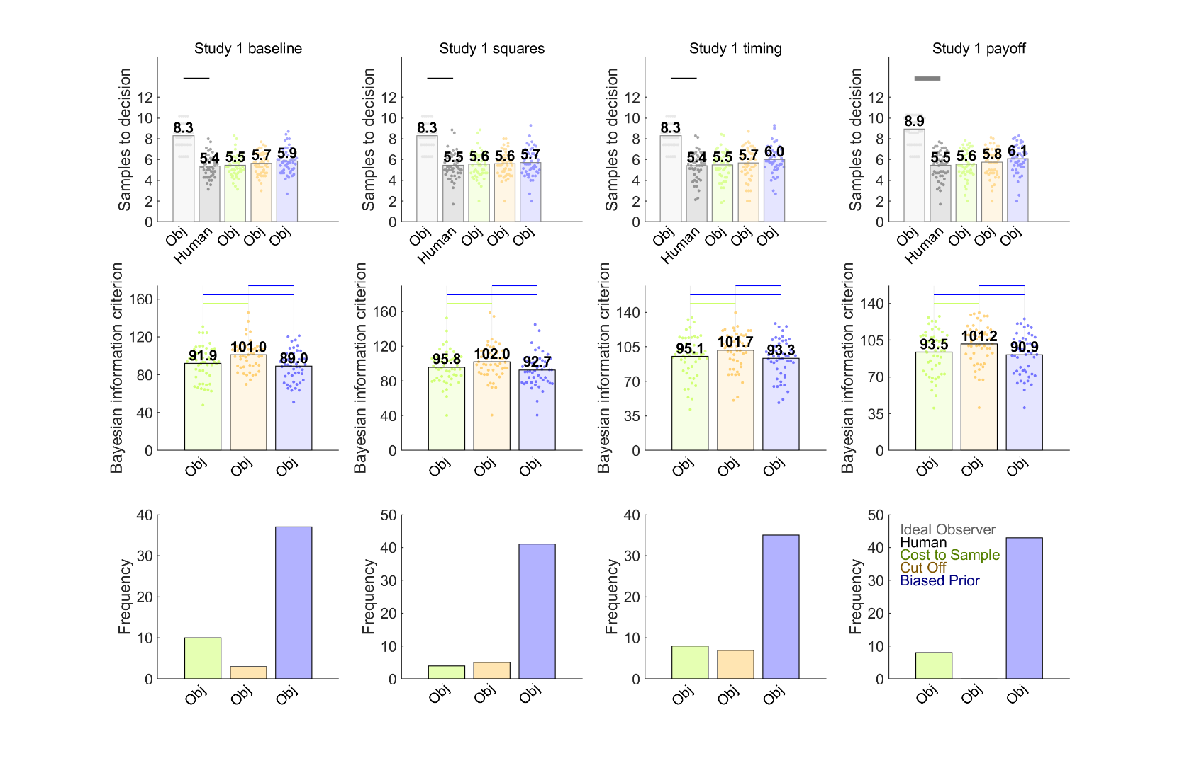

The first row of Figure 5 shows results for the two conditions with an initial rating phase (ratings and full), which therefore provide two versions of Ideal Observer, one based on subjective option values and the other based on objective values. Study 1 full is the only condition in Study 1 where participants (and the Ideal Observer) were instructed to maximise the rank of their choices, instead of using a scheme that rewards only the top-three ranked options. It is also only in the Study 1 full condition where the Ideal Observer sampled less than in the other conditions. Participant undersampling compared to both versions of Ideal Observer, subjective value (Cohen’s *d* = -1.20) and objective values (Cohen’s *d* = -1.72), is present for Study 1 ratings (left column), a condition in which the top three ranks are rewarded. However, undersampling in Study 1 full (right column) was eliminated for the subjective values version of the Ideal Observer (Cohen’s *d* = 0.19) and the effect size of undersampling was reduced by more than half for the objective values version (Cohen’s *d* = -0.61), though it retained significance.

Note that the results for Pilot full showed an elimination of undersampling altogether for both objective and subjective values versions of the Ideal Observer and even oversampling for the subjective values version, which is a somewhat more striking result than what we obtained for Study 1 full. In our next study (Study 2), we will resolve this apparent discrepancy by implementing a full condition with improved design elements and a statistically better-powered sample size. Provisionally, from Study 1, we conclude that undersampling bias was greater in all the conditions that rewarded only the top three highest ranked choices, compared to the only condition that used a payoff scheme that rewarded all choices commensurate with the chosen option value (Study 1 full).

Figure 5. Model comparison for Study 1 rating (left column) and full (right column) conditions. Points in the first and second rows show data corresponding to individual participants, while bars show their mean values. Human participant data are reproduced from Figure 2. In the top row, grey horizontal lines above human and Ideal Observer samples data indicate when *BF10* > 3 (moderate evidence for different means). Human and Ideal Observer sampling never showed *BF01* > 3 (moderate evidence for equal means). The second row shows BIC values (lower values indicate better model fit) for participants (points) and their mean values (bars). Horizontal lines are shown in the colour corresponding to the better-fitting model when *BF10* > 3 or in black when *BF01* > 3. In the rating condition, the Biased Prior model fits better than any other model (blue horizontal lines). In the full condition, the result is more ambiguous. Only the objective values version of the Biased Prior model shows some significant difference. The third row demonstrates that, in both conditions, the Biased Prior model best fitted the most participants. Abbreviations: Subj = Models that make choices about subjective values; Obj = Models that makes choices about objective values.

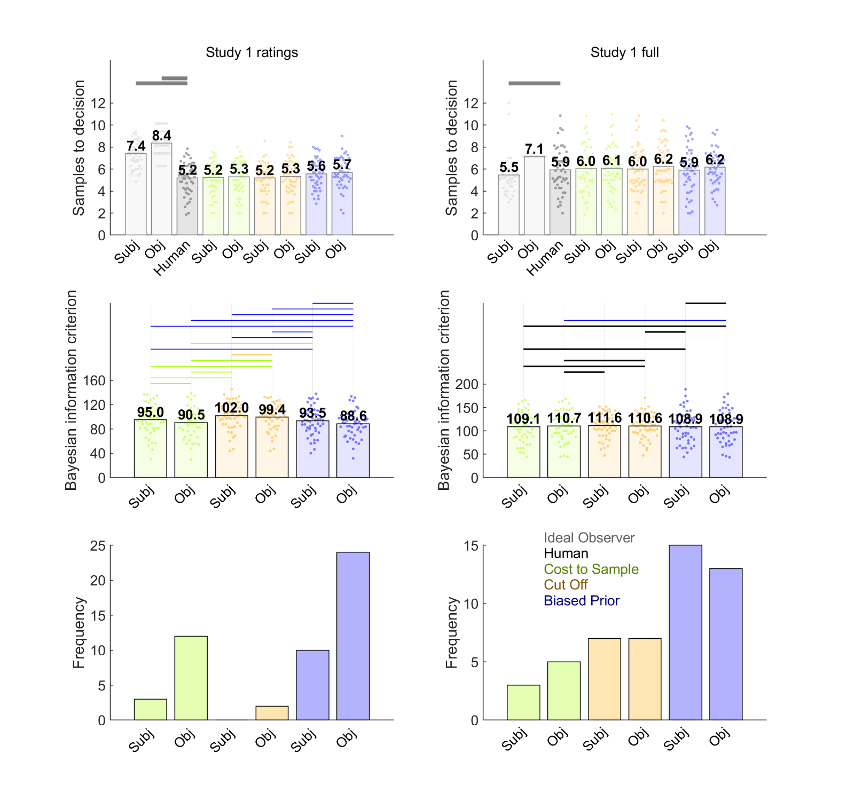

Lastly, we evaluated computational theoretical models that could explain biases in individual participants. All the conditions produced similar results. All four conditions in Figure 4 replicate unambiguous evidence favouring the Biased Prior model, based on both statistical tests on individual participant BIC values (middle row) and frequencies of best-fitted participants (lower row). For Study 1 ratings (Figure 5, left), the objective values version of the Biased Prior model dominated all other models. For Study 1 full, statistical comparisons of BIC values were somewhat ambiguous (Figure 5, middle right), perhaps because there was a less prominent bias to explain in this condition, compared to the others. Nevertheless, both subjective and objective value versions of the Biased Prior model best fitted the most participants (Figure 5, lower right). Overall, the evidence collectively favours Biased Prior models as the most common explanation of participants’ choices.

Study 2 Introduction

The Pilot full study and the Study 1 full condition showed that an optimal stopping task in which all choices are rewarded according to their value leads to reduced Ideal Observer sampling (i.e., the “full” conditions), compared to a raft of different conditions in which only the top three ranking choices were rewarded. Participants, in contrast, maintained relatively low and invariant sampling rates across all conditions. Consequently, the two full conditions (where there was not clear undersampling) created a situation where participants’ and Ideal Observer sampling rates were quite close to each other, making a direct assessment of bias in this condition difficult to determine with high precision. Our second study aimed to obtain a higher quality estimate of participant sampling bias in the full condition by overcoming some limitations of our previous designs. We increased the target sample size from approximately 50 (in Pilot full and Study 1 full) to 151 in Study 2 full. Additionally, we generated a new set of sequence option values for every participant, whereas in Pilot full and Study 1 full, all participants engaged with sequences that were fixed in advance. These design elements also provide largest dataset for theoretical model fitting yet. We also exploit this large dataset to implement some supplementary analyses for model validation purposes (See

Study 2 Methods).

Participants

One hundred fifty-one participants based in the UK enrolled, using the participant recruitment platform Prolific.

Procedures.

The study was developed in Javascript jsPsych 7.3.1 (de Leeuw et al., 2023). In phase 1, participants rated 90 prices (the same smartphone prices used in our three studies reported above) two-times each, with all stimuli presented in one random sequence. Prices appeared above a 1 to 100 scale, and participants indicated the “attractiveness” of each price via mouse click on the scale. The mean (over participants) Pearson’s correlation coefficient between the two ratings for each price was .85. Next, participants performed an optimal stopping task with six sequences of 12 price option values, randomly sampled without replacement from the 90 prices. The study implemented participant-paced screen timing. There were no grey squares. Instead, upon choice, the paradigm proceeded directly to the feedback screen. The feedback screen appeared as described above for Pilot full and Study 1 full. Participants were instructed to choose the best possible price.

Study 2 Results and Discussion

Participants appeared to sample about as many prices in Study 2 as in the previous studies reported herein (Figure 2). From Figure 6, which shows Bayesian pairwise test results comparing participants’ sampling to that of the two ideal observers (*BF01* > 3, moderate evidence for null model), we see that participants sample statistically equivalently to the objective values version of the Ideal Observer (Cohen’s *d* = .05) and oversample compared to the subjective values version (Cohen’s *d* = -0.32). Study 2 also replicated the model-fitting results we found throughout our studies reported herein, with the evidence favouring the subjective and objective values versions of the Biased Prior models as outperforming other models, especially in terms of the number of best-fit participants (Figure 6, lower row).

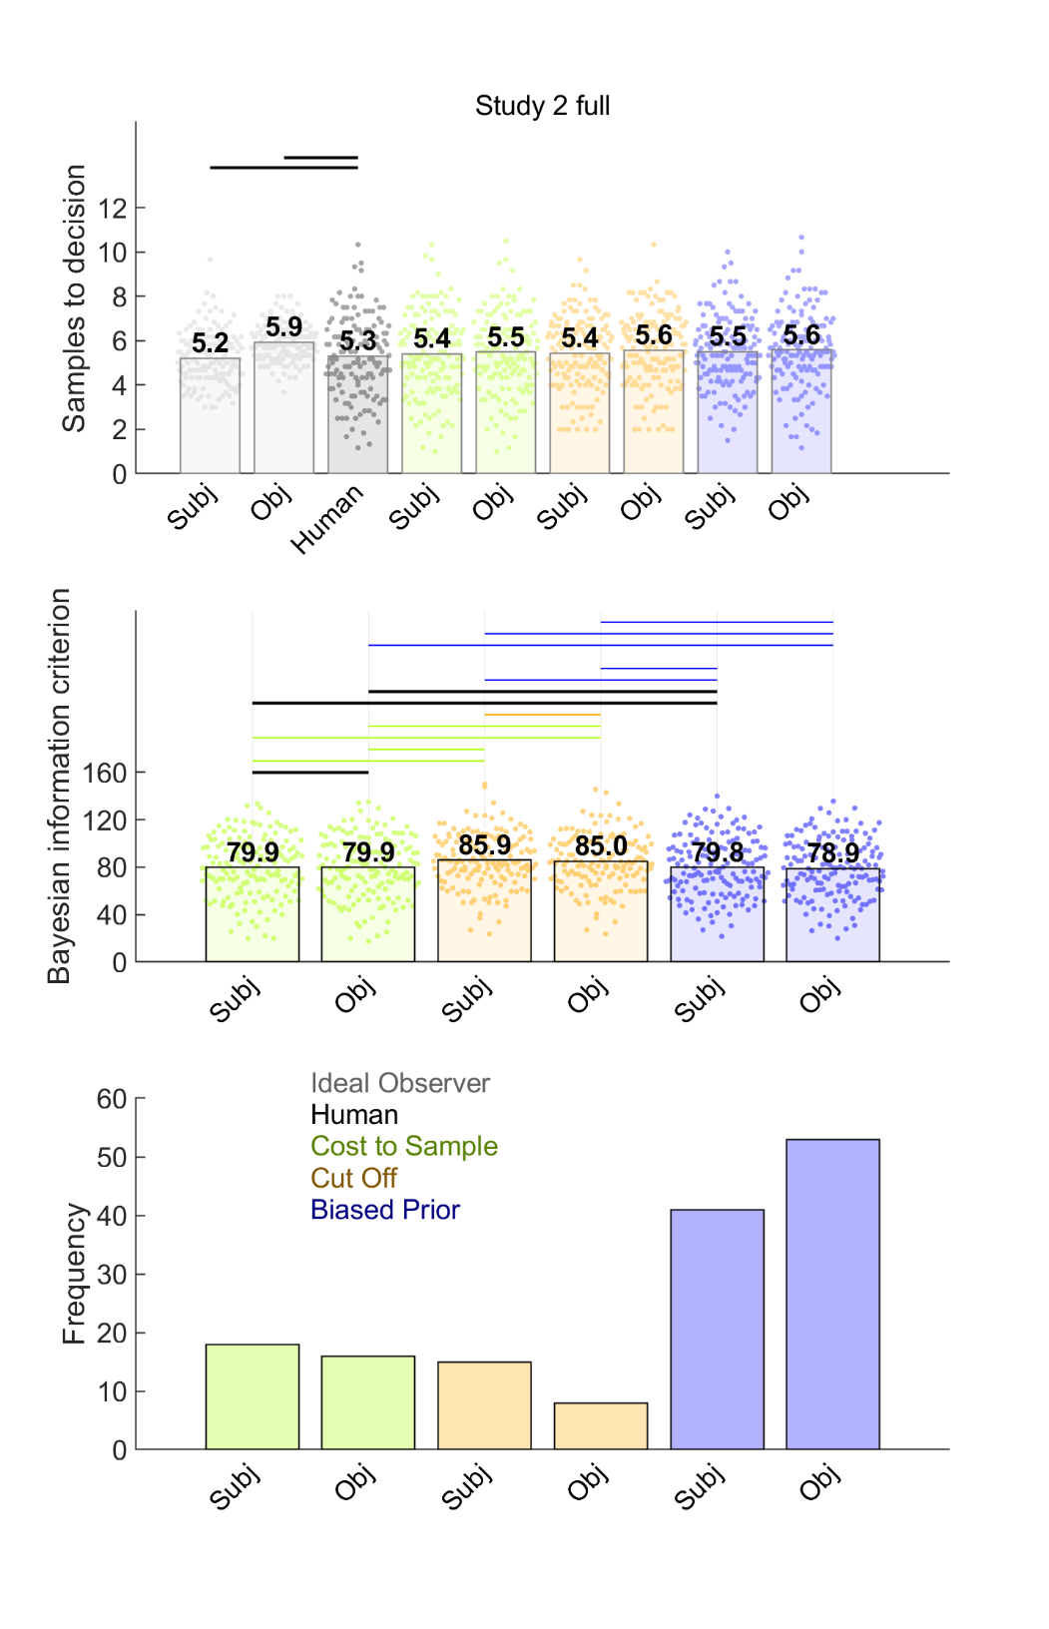

Figure 6. Model comparison for Study 2. Points in the first and second rows show data corresponding to individual participants, while bars show their mean values. Human participant data are reproduced from Figure 2. In the first row, human and Ideal Observer samples are demarcated by thin black horizontal lines when *BF01* > 3 (moderate evidence for equal means) or thick grey lines when *BF10* > 3 (moderate evidence for different means). The second row shows BIC values (lower values indicate better model fit) for participants (points) and their mean values (bars). Black horizontal lines indicate when *BF01* > 3. When *BF10* > 3, the horizontal line is coloured the same as the bar of the better model. The objective values version of the Biased Prior model shows superiority over most other models. Abbreviations: Subj = Models that make choices about subjective values; Obj = Models that makes choices about objective values.

Study 3 Introduction

Figure 2 suggests that participants are loath to change how much they sample. They are not sensitive to the presence or absence of the various methods features listed in Table 2. And, even though rewarding only the top three options leads the Ideal Observer to increase the number of options it samples, participants do not correspondingly increase how much they sample under this incentivisation scheme. The goal of Study 3 was to ensure that our implementation of the optimal stopping task was methodologically viable and that it is in practice possible to experimentally modulate how much participants sample at least to some degree. Costa & Averbeck (2015) manipulated the sequence length (i.e., how many options were available in each sequence) and found participants were willing to increase the number of samples for longer sequences. Nevertheless, Costa & Averbeck found that undersampling was more pronounced at higher sequence length. Participants in their study appeared reluctant to increase how much they sampled, whereas the ideal observer increased its sampling rate to adapt to the longer sequence lengths without constraint – a pattern that appears consistent with the reluctance with which participants increase their sampling rates in our studies reported herein. In our third study, we replicated this effect of sequence length on participants’ average number of samples, using sequence lengths of 10 and 14 options. We also took the opportunity to further replicate and bolster our conclusion that a biased prior is a worthy explanation of participants’ performance, using the two more datasets Study 3 provides.

Study 3 Methods

The preregistration of Study 3 can be found at <https://osf.io/vcf7u>. We enrolled 140 participants from the UK using Prolific, where half the participants engaged with sequences of length 10 and the other half engaged with sequences of length 14. As explained in the pre-registration, the sample size was intended to double that of Costa & Averbeck (who used a more powerful repeated-measures design and who were able to use more trials per participant in-lab, while we needed a shorter online study). The procedures were identical to Study 2, using the same jsPsych code, merely changing the sequence length of the optimal stopping phase of the study. The averages (over participants) of the Pearson’s *r* values computed between the two phase 1 ratings to each price were .88 for the 10 option condition and .84 for the 14 option condition.

Study 3 Results and Discussion

Figure 2 (rightmost bars) shows that our hypothesis was confirmed: participants sampled significantly more for longer sequences, replicating the findings in Costa & Averbeck (2015). As in Costa & Averbeck, undersampling was not observed for the shorter sequence length. In our study, the Bayesian tests (Figure 7) suggest that at a sequence length of 10 options, participants slightly *overs*ampled (rather than undersampled) compared to objective values version of the Ideal Observer (Cohen’s *d* = 0.33), while the difference with subjective values version remained inconclusive (Cohen’s *d* = 0.26). In contrast, participants showed clearer evidence for an undersampling bias at sequence lengths of 14, as they sampled statistically *less than* the Ideal Observer for both objective values (Cohen’s *d* = -.63) and subjective values (Cohen’s *d* = -0.44) versions. Our model-fitting also confirmed our hypothesis that participants’ sampling biases could be explained best by a Biased Prior model, though the Cost to Sample model clearly made a stronger contribution in Study 3 than Study 2. In summary, participants can and will change their sampling behaviour to some degree in some contexts. However, at least on tasks using the economic domain that we studied here, participants’ number of samples are “held in place” by a largely pessimistic expectation about the quality of upcoming samples (as in the Biased Prior model), which discourages them from increasing their sampling to the optimal degree and leads to increasing undersampling bias as sequences lengthen.

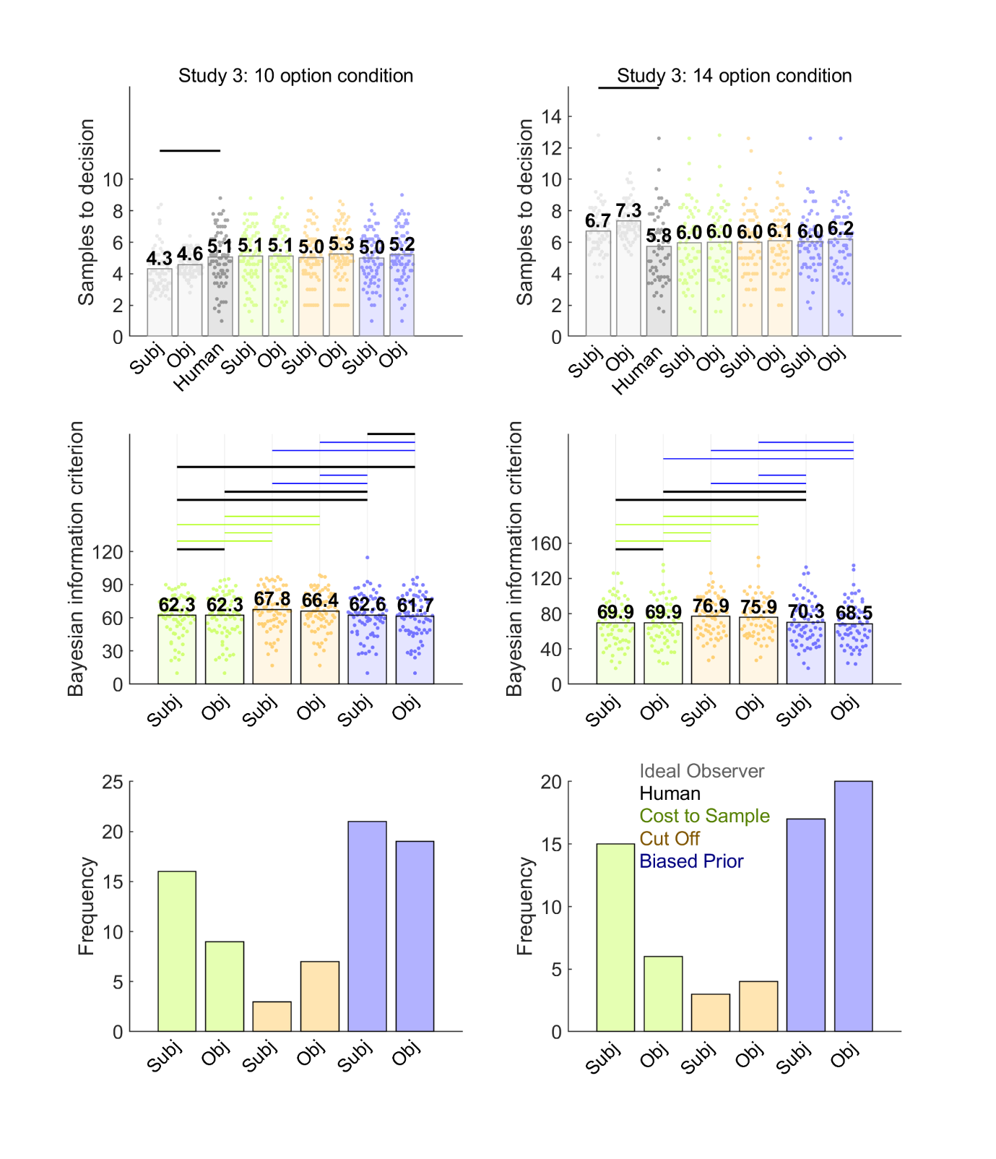

Figure 7. Model comparison for Study 3 10 options (left column) and 14 options (right column) conditions. Points in the first and second rows show data corresponding to individual participants, while bars show their mean values. Human participant sampling data are reproduced from Figure 2 and show a significant effect of sequence length (*P* < 0.05). In the first row, human and Ideal Observer bars are demarcated by grey lines when *BF10* > 3 (moderate evidence for different means). Neither humans nor the Ideal Observer showed *BF01* > 3 (moderate evidence for equal means). The second row shows BIC values (lower values indicate better model fit) for participants (points) and their mean values (bars). Black horizontal lines indicate when *BF01* > 3. When *BF10* > 3, the horizontal line is coloured the same as the bar of the better model. The third row demonstrates that the Biased Prior model best fit the most participants’ data, though the Cost to Sample model also accounts for some participants. Abbreviations: Subj = Models that make choices about subjective values; Obj = Models that makes choices about objective values.

General Discussion

Undersampling bias

In our pilot studies, we first established that we could replicate an undersampling bias (Baumann et al., 2020; Cardinale et al., 2021; Costa & Averbeck, 2015) by adapting a previous implementation of an economic full-information problem (Costa & Averbeck, 2015). In addition to this replication, we also tested novel task variables (used in other studies like van de Wouw et al., 2022) that hypothetically might modulate undersampling bias. We were able to modulate the size of the undersampling bias in two ways: by manipulating the payoff scheme and by manipulating sequence length.

Across three studies, we implemented so-called “full” conditions; the only condition where participants simply maximised the option value of their choices, rather than attempted to obtain one of the top-three ranked options. Every condition except these full conditions replicated robust participant undersampling, when compared to either objective or subjective values versions of the Ideal Observer. In contrast, in full conditions (except for sequence length 14), undersampling was inconsistent at best when compared to the objective values version of the Ideal Observer and was eliminated (or sometimes showed oversampling) when compared to the subjective values version. This contrast between full and non-full conditions was not because participants changed their sampling rate much. It was because the Ideal Observer sampled less in the full conditions.

The Ideal Observer reduced its sampling rate in the full condition because of its payoff scheme. The full condition also implemented a variety of task methods not present in Costa & Averbeck (2015), though we were able to experimentally eliminate as alternative possible causes of undersampling the other task features in the full condition, including screen timing, grey squares, extrinsic monetary reward, the presence of a first rating phase and the use of subjective or objective values in the Ideal Observer. Thus, we must conclude that, the Ideal Observer is willing to increase its sampling rate to the one appropriate for its payoff scheme (when the top three ranks are rewarded), while participants are not so willing (as they tend to always sample at nearly the same rate).

We observed a similar phenomenon in Study 3 for sequence length. Although both participants and the Ideal Observer increased their sampling rates for longer sequences (14 options compared to 10), the Ideal Observer showed a greater sampling increase for longer sequences than participants did, and thus the undersampling bias correspondingly increased – a finding replicated from Costa and Averbeck (2015). It appears that, while sometimes participants can increase their sampling, they generally prefer to limit how much they sample, even when it is optimal to increase sampling rate more than they do.

Theoretical modelling

Crucially, we were able to theoretically explain, in terms of a computational mechanism, participants’ sampling bias. Our model fits suggest that participants’ reluctance to increase sampling rates when it is optimal to do so arises because participants expect future option values to be lower on average than they will be. In the Biased Prior model, we added a constant to the mean of the prior “generating” distribution of option values. In cases where undersampling occurs, this constant appears to be negative (See, for example, Figure S9, middle row) – reflecting a pessimistic expectation. Participants of course still make some suboptimal decisions in these full conditions and our data suggests that mis-specified prior expectations may account for these suboptimal decisions as well.

We should note, however, that the Cost to Sample model – in which participants perceive sampling itself to be costly or rewarding – was the best-fitting model for a substantial number of participants and therefore may explain suboptimal decisions in a subset of our participants. Indeed, all our models accurately predicted participants’ mean sampling rates (Figures 3-7). The models did however diverge in their predictions of participants’ mean rank of chosen options (Figures S7, S9-S11, S14). Here, the Cut Off heuristic was unable to obtain similar levels as participants, while Biased Prior and Cost to Sample models could. Our supplementary analyses of the large sample in Study 2 show individual differences in participant sampling rates were highly correlated with sampling rates predicted by all three models (Figure S12). And, participants’ sequence specific thresholds were approximated by all three models (Figure S11). The framework we promote here, therefore – using an ideal observer to model accurate performance and then parameterising it to account for systematic bias – appears to produce models that predict participant data with reasonable accuracy. Moreover, different participants in the same sample might adopt any of these strategies, even if the Biased Prior strategy might be the most common. In some cases (as in Study 3), the Cost to Sample model best fitted a remarkable share of individual participants. Given the high predictivity of all our models, it can be difficult to discern exactly what choices the Biased Prior is superior at predicting, compared to other models. Our recommendation is that these models be compared on paradigms specifically designed to test this hypothesis. For example, manipulations of participants’ expectations about upcoming option values (i.e., their prior) should produce the types of systematically different decisions that would be predictable from a Biased Prior model.

Our study alone cannot explain whence this biased prior arises and this also opens new questions for future research. It is possible that participants, in economic contexts, might adopt a “safe” or conservative strategy (i.e., response bias) that protects against getting stuck with an especially poor outcome. Indeed, inspection of the ranks that participants achieved with their choices (a measure of their choice accuracy), shown in the first rows of Figures S7, S9-S11 and S14 suggest that the quality of participants’ choices closely approximated those of the Ideal Observer’s choices, despite their suboptimally low sampling rates. Consequently, one can adopt a pessimistic stance that protects from the uncertainty of a poor outcome and still “satisfices”; that is, perform at near-optimal levels.

The Biased Prior model appeared to garner replicated evidence across datasets whether participants had the opportunity to learn the prior distribution from a preceding ratings task (e.g., Study 1 ratings condition) or not (Figure 4). One possibility is that participants develop from the outside world a pre-conceived idea of the distribution of outcomes and new learning within the task (either from the ratings phase or from the sequence options themselves) fails to overwrite this preconception. Another possibility is that participants may learn the prior to some degree from the option values as they experience one sequence after another (Goldstein et al., 2020). However, we did not find learning effects across sequences here, consistent with previous reports of studies on full-information problems (Lee, 2006). Nor is it clear why this strategy would lead to a pessimistic prior and undersampling. Baumann et al. (2020) included a different approach from ours to using a learning phase prior to the optimal stopping task to ensure that participants were acquainted with the generating distribution. As in Lee and Courey (2020), participants learned abstract mathematical density functions. Based on these, participants drew histograms of distributions, on which they received feedback to ensure their understanding. According to Goldstein and Rothschild (2014), such a graphical elicitation technique can lead to rather accurate representations of probability distributions in participants. This approach is not likely to be especially ecologically valid, however. Another appealing explanation for participants’ apparently biased prior is that participants did not treat our task as a full information problem and did not use any prior distribution. Indeed, the Cut Off heuristic derives from a “prior-free” mathematical solution to the secretary problem, which gives optimal performance assuming that participants have no knowledge of the prior distribution. Nevertheless, the Cut Off heuristic did not perform well in our model comparison, in contrast to the Cost to Sample and Biased Prior models which are based on the full information problem solution. More research into how participants learn option value distributions would be useful. We hypothesise that a biased prior might persist, regardless of how participants are exposed to the prior, though more study is needed to generalise beyond our study.

Although we were unable to reliably induce participants to oversample in the present work and instead we identified variables that modulate the size of undersampling bias, others like van de Wouw et al. (2022) have demonstrated and replicated oversampling bias. Their work, rather than presenting options as numeric prices as we did here, communicated option values using images, such as the attractiveness of faces, foods and holiday destinations. Our manipulations of task features in Study 1 have already tested and rejected other task differences used in their paradigm that might give rise to oversampling (e.g., grey squares, timing, etc), leaving the pictorial stimulus domains as the most likely instigator of oversampling in van de Wouw et al. (2022). It is possible that a biased (i.e., overly optimistic) prior might account for oversampling in image-based contexts as well as undersampling in number-based, economic domains.

This is the first comprehensive comparison of theoretical models that specify the computations humans use to solve full information problems. Costa and Averbeck (2015) introduced the parameterised cost-to-sample model that we consider here and fitted that model to participants’ sampling choices in an economic full information task. However, they did not perform a model comparison with alternative models. Moreover, our current study provides a comprehensive parameter recovery analysis for this model and introduces and tests other similar theoretical models. Our work also builds on the approach recently taken by Baumann et al. (2020), who compared the objective values version of the Cut Off heuristic we consider here with “threshold models” (Lee, 2006). Although these threshold models are useful tools for directly estimating participants’ choice thresholds at each sequence position from participants’ behavioural data, we took a different approach for our model comparison. Our approach was to compare models that are “computational” in the sense that they specify the computations that participants might theoretically be using to accurately solve the task: most important, they specify how participants compute their decision thresholds. In the parameterised Costa & Averbeck (2015) models we considered, the action value for sampling again (See Methods) acts as the effective decision threshold, which varies over trials depending on the perceived prospect of sampling a better option value, and which the value of the current option needs to exceed before the model will commit to a choice. The models we used need not resort to explicit parameterisation of the thresholds, as they arise naturally from the computations within the model. Moreover, we obtain the added capability of parameterising bias terms and then simulating how these bias terms influence the computation of thresholds, which cannot be done using threshold models, at least as they have been implemented in the past. Perhaps future developments of these models can add some specification of how bias might come to alter threshold computation.

Limitations

We have introduced a framework whereby optimality solutions including that of the Secretary Problem and that of the full information problem have been leveraged to explain accurate performance on optimal stopping tasks. And our framework has taken the approach of parameterising these models to explain systematic sources of suboptimal performance. Given that we have proposed this framework and demonstrated its utility, we expect that future research can refine the models we have proposed or build improved models that may better fit participant data. For example, more complex models that combine multiple bias-related free parameters (e.g., the cost to sample parameter and a constant added to the prior mean as fitted parameters at the same time) might be considered. Also, more sophisticated versions of our models might be formulated, such as cost to samples that change across sequence position.

When considering models that might be built and tested in the future, it is worth considering that the Bayesian ideal observer solution to the full information problem (which we used as a base for some of our models) is relatively computationally complex, especially its backwards induction algorithm (See Supplementary Materials for more information). Future research might explore models that use a limited-capacity backwards induction, which can only partially explore possible future states, or create some simpler heuristic to approximate the choice threshold / value of sampling again. We note that already our evidence here undermines the case for a previously proposed heuristic, the Cut Off heuristic. In any case, we do not know the capacity of the neural architectures involved in solving these problems, rendering it difficult to reject models *a priori* on this basis. Indeed, it is plausible that neurons may be implementing similar computations as the kinds of models we investigated here. It has already been shown that brain responses correlate trial-by-trial with fluctuations in quantities derived from backwards induction based optimal stopping models that have been fitted to human participant choice data (Costa & Averbeck, 2016; Furl & Averbeck, 2011).

We have already mentioned several ways that the modelling framework we propose here and the results we have obtained raise new research questions and open new research lines. One last issue that we also feel deserves further study relates to the extent to which systematic bias translates into real losses for people confronted with real optimal stopping problems. We have already proposed above an interesting theoretical possibility that biases like Biased Prior strategies might have an adaptive function, so long as they can maintain near-optimal performance. Indeed, within the narrow range of sequence lengths and domains (i.e., smartphone prices) that we have examined here, participants’ biased choices largely satisficed, and produced performance that, while not optimal, did not cause a striking loss for participants, when measured as rank of chosen option. Nevertheless, we also show herein that factors such as sequence length and incentivisation can affect the size of bias (e.g., longer sequences increase undersampling bias, as the Ideal Observer adjusts to the longer sequences but participants less so). Just how large biases can eventually become and the extent to which significant losses might accrue for agents due to ever larger biases cannot be answered directly by our data and would benefit from more targeted investigations. Ideally, future studies could better approximate real-world conditions of decision making, or even collect field data “from the wild”, to assess what kinds of losses might (or might not) occur under more ecologically valid conditions, as opposed to the more tightly controlled studies we report here.

Conclusion

In summary, we show that the sampling rate of the Ideal Observer (which reflects optimal performance) is relatively more sensitive than those of participants to (at least) manipulations of payoff schemes and sequence lengths, such that these two factors can modulate the degree of undersampling bias. We explain participants’ sampling behaviour using a theoretical model by which participants implement optimal Bayesian computations to solve the task accurately, but a systematic undersampling bias develops when participants mis-predict the quality of upcoming sampling, based on biased beliefs about the probability distribution of outcomes.

Data availability statement

Data are available at <https://github.com/nicholasfurl/Model_fitting_hybrid_study>.

Code availability statement

Code is available at <https://github.com/nicholasfurl/Model_fitting_hybrid_study>.

References

Anwyl-Irvine, A. L., Massonnié, J., Flitton, A., Kirkham, N., & Evershed, J. K. (2020). Gorilla in our midst: An online behavioral experiment builder. Behavior Research Methods 52, 388–407. <https://doi.org/10.3758/s13428-019-01237-x>

Averbeck, B. B. (2015). Theory of choice in bandit, information sampling and foraging tasks. *PLoS Computational Biology 11*, e1004164. <https://doi.org/10.1371/journal.pcbi.1004164>

Baumann, C., Singmann, H., Gershman, S. J., & von Helversen, B. (2020). A linear threshold model for optimal stopping behavior. *Proceedings of the National Academy of Sciences 117,* 12750–12755. <https://doi.org/10.1073/pnas.2002312117>

Cardinale, E. M., Pagliaccio, D., Swetlitz, C., Grassie, H., Abend, R., Costa, V., Averbeck, B. B., Brotman, M. A., Pine, D. S., Leibenluft, E., & Kircanski, K. (2021). Deliberative choice strategies in youths: Relevance to transdiagnostic anxiety symptoms. *Clinical Psychological Science*, 1–11. <https://doi.org/10.1177/2167702621991805>

Castellano, S., Cadeddu, G., & Cermelli, P. (2012). Computational mate choice: Theory and empirical evidence. *Behavioural Processes, 90,* 261–277. <https://doi.org/10.1016/j.beproc.2012.02.010>

Castellano, S., & Cermelli, P. (2011). Sampling and assessment accuracy in mate choice: A random-walk model of information processing in mating decision. *Journal of Theoretical Biology, 274,* 161–169. <https://doi.org/10.1016/j.jtbi.2011.01.001>

Costa, V. D, & Averbeck, B. B. (2015). Frontal-parietal and limbic-striatal activity underlies information sampling in the best choice problem. *Cerebral Cortex* *25,* 972–982. <https://doi.org/10.1093/cercor/bht286>.

de Leeuw, J.R., Gilbert, R.A., & Luchterhandt, B. (2023). jsPsych: Enabling an open-source collaborative ecosystem of behavioral experiments. Journal of Open Source Software, 8(85), 5351, <https://joss.theoj.org/papers/10.21105/joss.05351>.

Ferguson, T. S. (1989). Who solved the secretary problem? *Statistical Science 4*, 282–289. <https://doi.org/10.1214/ss/1177012493>

Freeman, P. R. (1983). The secretary problem and its extensions: A review. *International Statistical Review / Revue Internationale de Statistique 51*, 189–206. <https://doi.org/10.2307/1402748>

Furl, N., Averbeck, B. B., & McKay, R. T. (2019). Looking for Mr(s) Right: Decision bias can prevent us from finding the most attractive face. *Cognitive psychology, 111,* 1–14. <https://doi.org/10.1016/j.cogpsych.2019.02.002>

Furl, N. & Averbeck. B.B. (2011). Parietal cortex and insula relate to evidence seeking relevant to reward-related decisions. *Journal of Neuroscience, 31,* 17572-82. <https://doi.org/10.1523/JNEUROSCI.4236-11.2011>

Gilbert, J. P., & Mosteller, F. (1966). Recognizing the maximum of a sequence. *Journal of the American Statistical Association, 61*, 35–73. <https://doi.org/10.2307/2283044>

Goldstein, D. G., McAfee, R. P., Suri, S., & Wright, J. R. (2020). Learning When to Stop Searching. *Management Science 66,* 1375–1394. <https://doi.org/10.1287/mnsc.2018.3245>

Goldstein, D. G., & Rothschild, D. (2014). Lay understanding of probability distributions. *Judgment and Decision Making 9*, 1–14. <https://doi.org/10.1287/mnsc.2018.3245>

Guan, M., & Lee, M. D. (2018). The effect of goals and environments on human performance in optimal stopping problems. *Decision 5,* 339–361. <https://doi.org/10.1037/dec0000081>

Guan, M., & Stokes, R. (2020). A cognitive modeling analysis of risk in sequential choice tasks. *Judgment and Decision Making 15,* 823–850.

Kolling, N., Scholl, J., Chekroud, A., Trier, H. A., & Rushworth, M. F. S. (2018). Prospection, perseverance, and insight in sequential behavior. *Neuron 99,* 1069–1082. <https://doi.org/10.1016/j.neuron.2018.08.018>

Lee, M. D. (2006). A hierarchical Bayesian model of human decision-making on an optimal stopping problem. *Cognitive Science 30,* 1–26. <https://doi.org/10.1207/s15516709cog0000_69>

Lee, M. D., & Courey, K. A. (2020). Modeling Optimal Stopping in Changing Environments: A Case Study in Mate Selection. *Computational Brain & Behavior 4*, 1–17. <https://doi.org/10.1007/s42113-020-00085-9>

Lee, M. D., O’Connor, T. A., & Welsh, M. B. (2005). Decision-making on the full information secretary problem. *Proceedings of the Twenty-Sixth Conference of the Cognitive Science Society*, 819–824.

Matejka, J., Glueck, M., Grossman, T., & Fitzmaurice, G. (2016). The effect of visual appearance on the performance of continuous sliders and visual analogue scales. *Proceedings of the 2016 CHI Conference on Human Factors in Computing Systems*, 5421–5432

Prolific. (2014). Available at: <https://www.prolific.co>

Scholl, J., Trier, H. A., Rushworth, M. F., & Kolling, N. (2022). The effect of apathy and compulsivity on planning and stopping in sequential decision-making*. PLoS Biology 20*, e3001566. <https://doi.org/10.1371/journal.pbio.3001566>

Seale, D. A., & Rapoport, A. (1997). Sequential decision making with relative ranks: An experimental investigation of the "secretary problem". *Organizational Behavior and Human Decision Processes, 69,* 221–236. <https://doi.org/10.1006/obhd.1997.2683>

Seale, D. A., & Rapoport, A. (2000). Optimal stopping behavior with relative ranks: The secretary problem with unknown population size. *Journal of Behavioral Decision Making, 13,* 391–411. [https://doi.org/10.1002/1099-0771(200010/12)13:4<391::AID-BDM359>3.0.CO;2-I](https://doi.org/10.1002/1099-0771(200010/12)13:4%253C391::AID-BDM359%253E3.0.CO%3B2-I)

Sonnemans, J. (2000). Decisions and strategies in a sequential search experiment. *Journal of Economic Psychology 21,* 91–102. <https://doi.org/10.1016/S0167-4870(99)00038-0>

Todd, P.M. & Miller, G.F. (1999). From pride and prejudice to persuasion: Satisficing in mate search. In G. Gigerenzer & P.M. Todd (Eds.), *Simple Heuristics that Make Us Smart*, pp 287–308. New York, NY: Oxford University Press.

Valone, T.J., Nordell, S.E., Giraldeau, L-A. & Templeton, J.J. (1996). The empirical question of thresholds and mechanisms of mate choice. *Evolutionary Ecology, 10,* 447–455.

van de Wouw, S., McKay, R., Averbeck, B. J., & Furl, N. (2022). Explaining human sampling rates across different decision domains. *Judgment and Decision Making* *17*, 487-512. <https://doi.org/10.1017/S1930297500003557>

Zwick, R., Rapoport, A., Lo, A. K. C., & Muthukrishnan, A. V. (2003). Consumer sequential search: Not enough or too much? *Marketing Science 22*, 503–519. <https://doi.org/10.1287/mksc.22.4.503.24909>